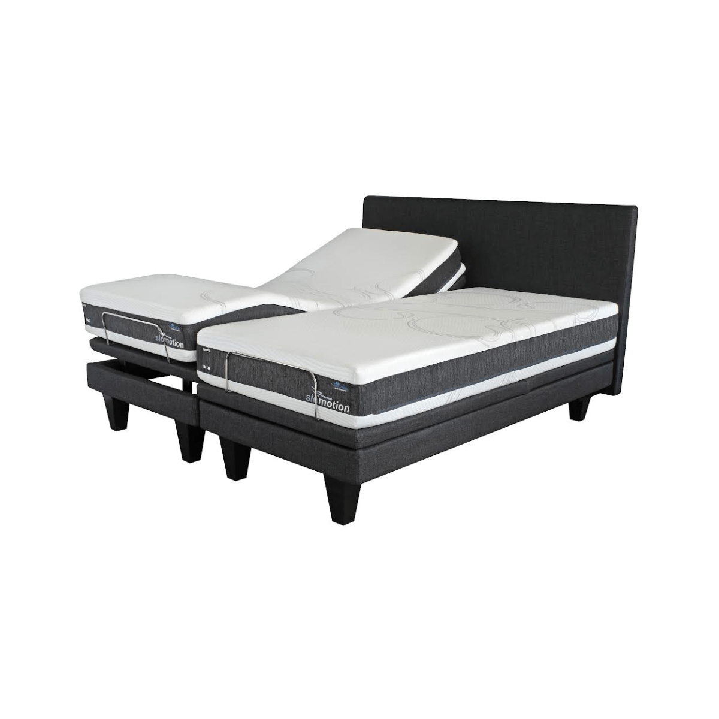


Model : Slow Motion King Extra Length Bed Set
Supplier/Manufacturer : Cloud Nine
Range : Slow Motion
Prices – Bed Set : Only Available in King Extra Length
- Bed Set Without Headboard – R100000
- Bed Set with Headboard – R115000
*Please use this link for guideline for creating the page – the video is a great touch as well* - https://www.bedsonline.co.za/product/cloud-nine-slomotion-king/?gad_source=1&gad_campaignid=23059240524&gbraid=0AAAAADim7kX1qRfoUgl1u9YtbYZwIoFEv&gclid=Cj0KCQjwsMLSBhD9ARIsAIpUTDr5xEUjUE5mXHEZDsShCaSSqjCRJ3dpumIzs3vJuy_NFb8X48LVVYEaAt15EALw_wcB
Cloud Nine Link - https://cloudnine.co.za/slomotion/

